………………………………………………………………………………………………………

**PERSONAL DETAILS**

Name: Smith Thapa

Address: 22 Gilroy Street, Ropes Crossing, NSW 2760

Telephone: 0416762880 (Mobile)

Email: [smith10rooney@gmail.com](mailto:smith10rooney@gmail.com)

Portfolio Website: [thapa.dev](https://thapa.dev/)

………………………………………………………………………………………………………

**CAREER OBJECTIVE**

A recent graduate looking for the position of a junior web developer where I can apply my knowledge and skills of creating beautiful and user-friendly web applications. Ability to solve problem with logical thinking, time management and excellent communication skills will ensure a positive contribution to any working environment.

………………………………………………………………………………………………………

**EDUCATION**

|  |  |  |  |
| --- | --- | --- | --- |
| **Year** | **Course** | **Institution** | **Achievements** |
| 2017 to 2019 | Bachelor of Information Technology | **Central Queensland University**  Sydney, Australia | * CQUniversity VC Scholarship * Software development as a major |
| 2014 to 2016 | Higher School Education Board | **SOS Hermann Gmeiner School**, Pokhara, Nepal | * Intermediate in Science (Mathematics) |

………………………………………………………………………………………………………

**WORK EXPERIENCE**

**June 2019 -**  *Now*

**Customer Service Assistant** (Part Time)

Chemist Warehouse, Bondi Junction

Sydney, Australia

**Responsibilities:**

* To provide exceptional customer service and serve customer queries and escalate the problems and dissatisfaction to related manager.
* Replenishing shelves and rotation of products to avoid expiration.
* Work as a team to complete short-term goals such as completion of load, cleaning of shelves.

………………………………………………………………………………………………………

**WORK SKILLS MATRIX**

|  |  |  |
| --- | --- | --- |
| **Skill** | **Level** | **Experience** |
| Java | Competent | * Self-taught over 3 years * University courses |
| Java EE (Enterprise Edition) | Good | * University course |
| Node JS | Competent | * Self-taught over 2 years |
| Database (MongoDB, MySQL) | Competent | * Database University Course * Udemy Database Courses |
| React JS | Competent | * Udemy Courses * Self-taught over 1 year |
| Python (Data Analysis and Visualization) | Good | * Data Science University Course * Data Analysis course from Coursera |
| Knowledge of Networks  (WAN/LAN/Routers/Switches) | Good | * CQUniversity IT Support * University taught |
| Front End Core  (HTML/CSS/SASS) | Competent | * University courses/units * Self-taught over 4 years |
| Microsoft Office Package and G suite | Competent | * CQUniversity IT Support * University Assignment Work * Self-taught over 8 years |
| Time management and ability to work under pressure | Competent | Experiences from   * University deadlines * Chemist Warehouse * Oporto |

………………………………………………………………………………………………………

**CERTIFICATES/LICENCES**

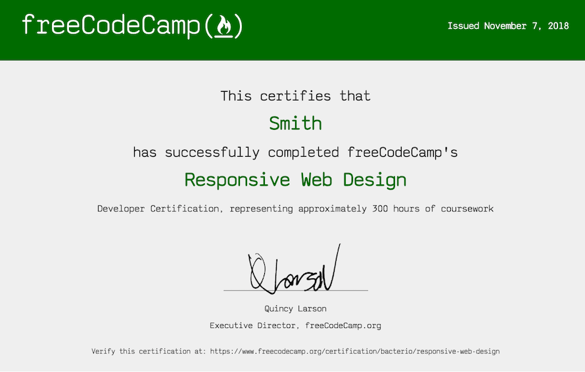

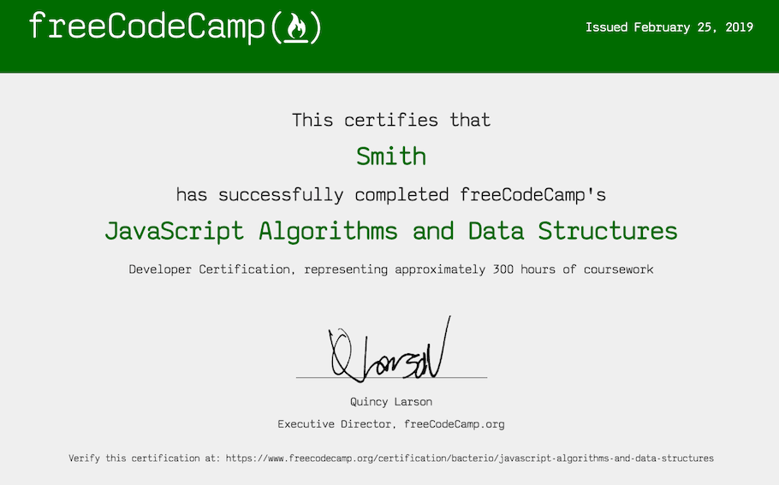

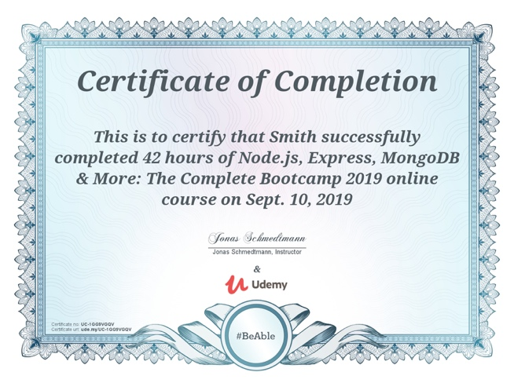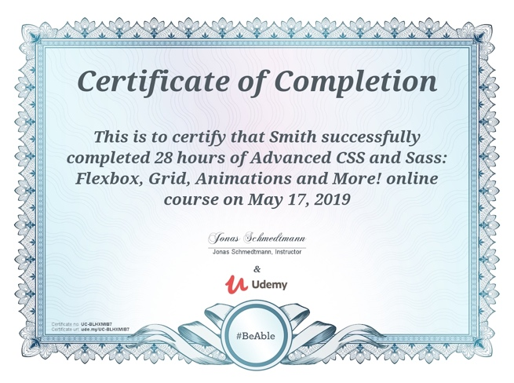 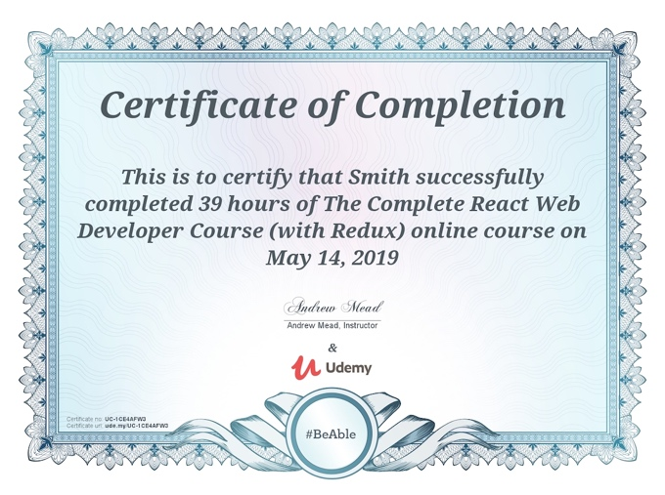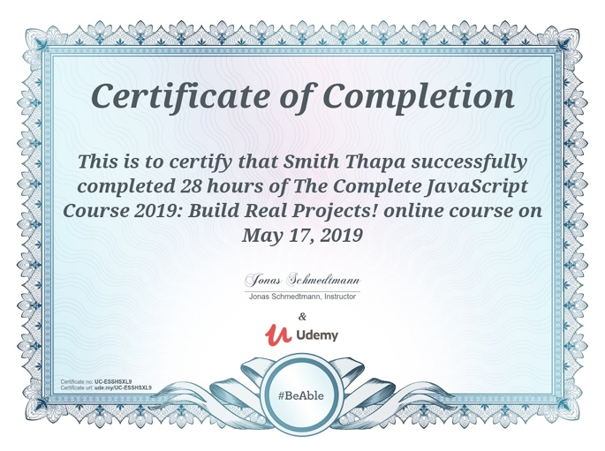

Current Class C NSW driver’s license

Current NSW Working with Children Check (WWCC) clearance

………………………………………………………………………………………………………

**ACHIEVEVEMENTS AND AWARDS**

2017 CQ University Vice Chancellor Scholarship

2012 3st in Interstate Chess Competition, SOS Hermann Gmeiner School

2012 1st in Interschool Essay Competition, SOS Hermann Gmeiner School

………………………………………………………………………………………………………

**HOBBIES AND INTERESTS**

* Sports: Football, Chess
* Bicycling and Hiking.
* Suspense, Mystery and Sci-Fi Novels